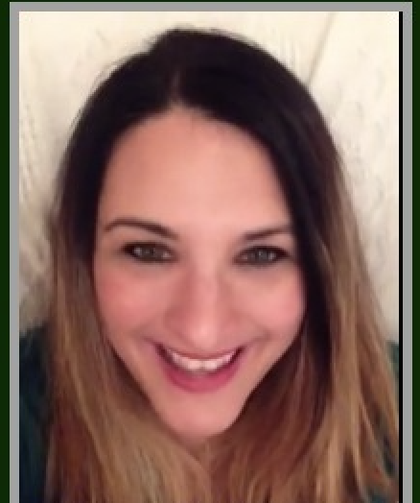
6 Caston Way Boynton Beach, FL 33426 615-383-4812 mg@michellegold.com

Summary:
Friendly, warm, and positive teacher/coach with twenty-years plus experience. Known for training students in developing the most excellent voice techniques & performance skills which serve to touch the hearts of audiences far and wide. Experience as a teacher includes private schools in NYC, Nashville, TN & Boca Raton, as well as leading music tour with a world-renown ministry across the US and Europe as director of music.

Ms. Michelle’s experience also includes being a featured artist on National Television: both CBN & Discovery Channel. She has been opening artist & has performed for industry leaders such as Gladys Knight, Lena Horne, Leadership at World Vision, El Salvador, Chosen People Ministries, and for former mayor of New York, Rudy Giuliani. She also has four independently released albums available on Apple (Who Will Go?; Quien Ira; You Know Me ; & her latest, Presence) & has authored a music biography called, Finding Gold sold on Amazon.com.

Michelle specializes in preparing & partnering with singers to create excellent performances in a fun & free-spirited environment. As a bonus, Michelle is able to teach songwriting and accompanying techniques individually and in group settings. Her greatest fulfillment is in passing on these skills and in showing how music can help us keep a joyful and resilient outlook on life.

Michelle is married to minister Joe Franco, has two children: Bella and Micah and a golden doodle named Mickey. When she is not singing, she enjoys Israeli Dance, Rosetta Stone Spanish, swimming, & watching all the latest and greats films and shows.

Experience:

Travelling Musician: Concerts & Events as Singer/Songwriter with husband, Minister Joe Franco, 1995-present

Highlights include:
Opening for Integrity Records Artist, Paul Wilbur
Ministering to the families of firefighters lost in 911 at St Patrick’s Cathedral, NYC
Sharing testimony & Music Internationally on LIVE TV: CBN & Discovery Channel
Special Holiday Services, Memorials, Marriage & Women conferences
Christian Albums Released between touring: You Know Me, 2005; Who Will Go? 2014; Quien Ira? 2019

Professional Voice Teacher & Performance Coach: (Ages 7-17)
Training singers in Pop, Broadway, Classical & Gospel music. Students included pre-teens, teens, & mothers of small children, Independent as well as signed artists like Jordan Elias, Galilee of the Nations Records.

Green Art Music Studio, Boca Raton, 2015-2019 (Formerly BRAVO Music School)

iVoice School: Nashville, TN, 2008-2010

Vocal Coach for world re-known Jewish ministry group, Liberated Wailing Wall, on Tour Bus 2005-2006

Startime Music Studio, Brooklyn, NY 1998-2000

Co-Leader of Worship Music:

Co-Leader of Worship Music with South FL Regional YOUTH, sponsored by Ft. Lauderdale & Sunrise, FL Congregations, 2018- present (Messianic Rabbi Joe Vitkus and Rabbi Gabriel Simkin)

Co-Leader of Worship Music: Light of Israel Fellowship, Boynton Beach, FL 2014- 2018
Co-leading worship with Rev. Jim & Rebecca Fox sponsored by Chosen People Ministries Director and Pastor, Richard Freeman

Cantor & Co-Leader of Worship: L’Chaim Messianic Temple, Boynton Beach, FL 2016- 2017
Co--leading worship with various leaders, Pastor Bruce & Suzie Elman

Co-Leader of Worship Music: Kol Dodi Messianic Congregation, Nashville TN – 2008-2009
Co-lead worship services with Rabbi Ken Alpren

Music Tour/Music Director, The Liberated Wailing Wall US & European Tour, Jews for Jesus:
San Francisco, CA, 2005-2007
As Music Director for this 7-person Musical Group, I was responsible for directing all musical aspects of the performances, rehearsals, songwriting, album recording and tour as mentored Jeff Millenson. Our group conducted over 350 concerts in a 20-month span, touring the United States, Canada, Great Britain, France, Germany, Switzerland and Israel.
Duties included:
Managing, tweaking & enhancing the team’s daily performance to keep performances fresh & spirit-led
Overseeing team music rehearsals, both on and off of the _{Motor}-coach, teaching new songs and reviewing existing repertoire
Organizing & writing music charts for new Holiday Music
Directing & facilitating weekly practice/group rehearsals and schedule for team
Conducting songwriting training seminars with team members, resulting in having 7 songs chosen to be a part of Jews for Jesus’ latest published album, Never Forget (released October 2007).

Education: Manhattan School of Music, New York, NY – BA, Classical Voice 1997
Light University, Life Coaching Certificate 2023

Sought after Workshops Attended:
Songwriters Hall of Fame: Immersive Classes in Performance & Songwriting Lorraine Ferro (Nashville Songwriter & contestant of The VOICE, NBC)

On Stage Success with Tom Jackson: Extensive Performance Workshop & training with sought after Christian spirit-led coach, Tom Jackson, https://onstagesuccess.com, Nashville, TN

Music Together (Mommy & Me Program), LLC Certified

Awards: 1st Place: Greatest American Songwriting Contest, 2019 ( Inspirational Christian Category for song: “Shalom”) Lena Horne Scholarship, 1991, McDonalds GospelFest Finalist, GMA Spotlight Gospel Finalist, 2000
“Outstanding Achievement in Songwriting Award,” 2020 (for Song “Into His Presence” with Greatest American Songwriting Contest, Inspirational Christian Category

References will be furnished upon request

